**Fork-You**

**Collaboration LAB for Group Use**

This project is created to help participants understand the process of contributing to an open source or group project.

1. Go into your Organization **https://github.com/Shari-Geek/Fork-you**
2. Open the repository "**Fork-you**"
3. **Star** the repository

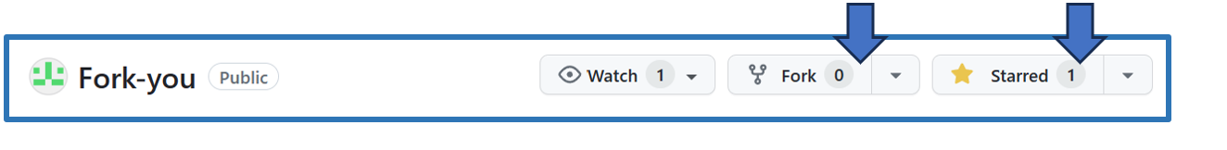

1. **Fork the repository.**

This will create a new fork in GitHub IN YOUR PERSONAL ACCOUNT.

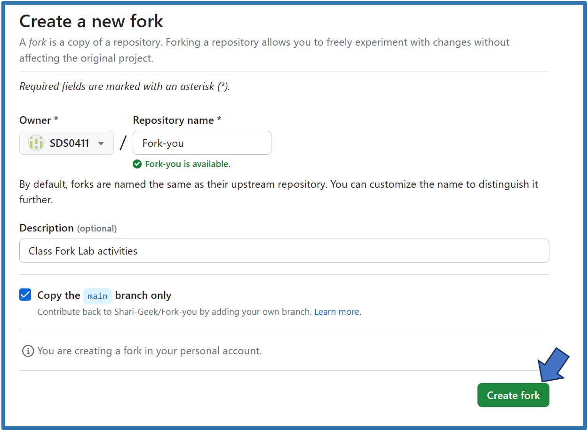

1. click on "fork"
2. enter a repository name: default: Fork-You (be default, they are named the same as the parent repository)
3. enter a description: example: Our Class Collaboration LAB for Group Use
4. check "Copy the main branch only"
5. press "**CREATE FORK**"
6. Now Clone the fork you just created in GitHUB to your Local computer.

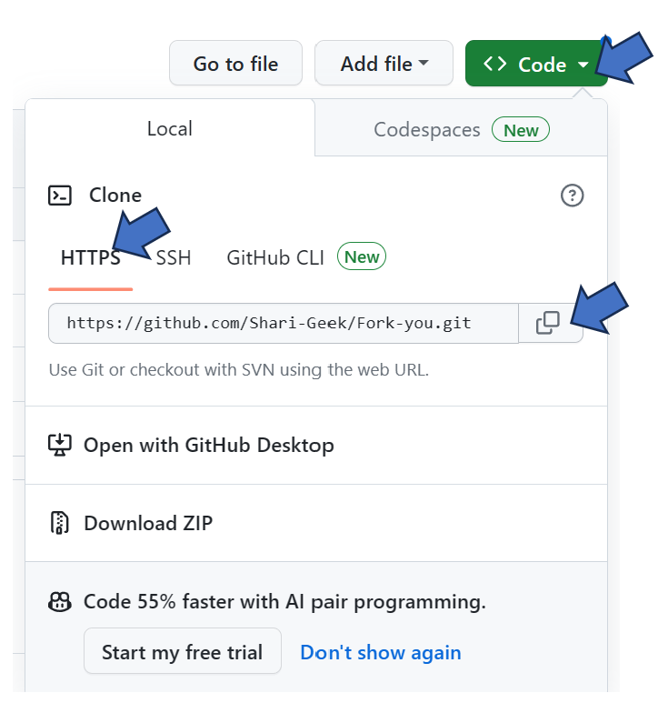

Note: open PowerShell  on your local computer.  
 Replace the GIT URL with your-GIT-URL

**git** **clone** <your-GIT-URL>

1. Create a **new branch** on the local REPOSITORY you just cloned.

**git** **checkout -b** use-your-name-branch (*example: git checkout -b toms-branch)*

My example created a new branch called "*shari-branch*" and checked it out. The new branch has the commit history of the master branch you started from.

1. Open Contributors.MD and enter the following details

**Name:** [Your Name] (GitHub Link)

* **Place:** City, Country (somewhere, anywhere really)
* **Bio:** Who are you? (think Walter Mitty)
* **GitHub:** [Your Name] (GitHub Link)

1. Commit the updated file to your new branch

git add Contributors.md

git commit -m "Added myname to Contributors.md"

git push origin use-your-name (example git push origin toms-branch)

You will be informed in the response where to go on GitHub to create a Pull Request.

1. In Your Personal Repository in GitHub, Create a **Pull Request** and add the title as "Added *myname* to Contributors.md"
2. Wait for the changes to be merged by the repository owner (You) on GitHub, or you can merge via command line.

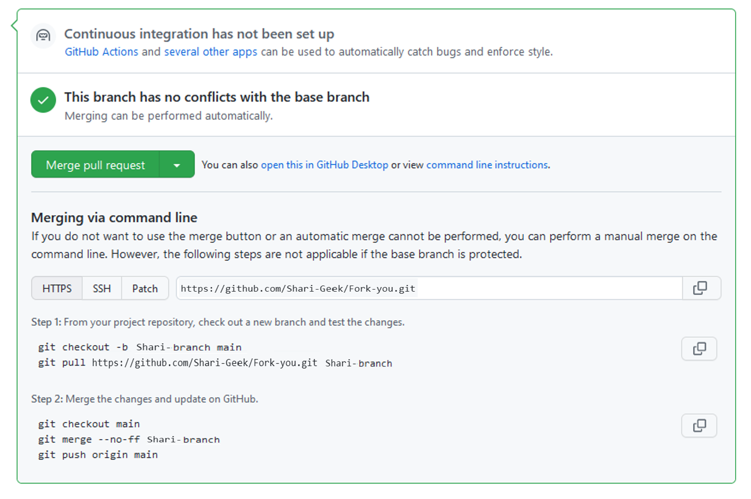

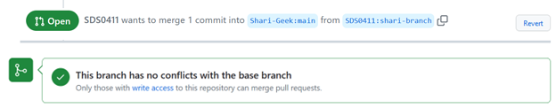

**Syncing a Fork**

The instructions above work if you want to push something once, or need help to merge the file(s).

But what if you want to contribute more often, or want to **sync back with the original**?

Here's how:

1. Add a remote for the original project to your local repository. This hooks your fork copy with the original repository.

git remote add upstream https://github.com/Shari-Geek/Fork-you

1. Now update your repository with the original

git pull upstream main

1. Now update your fork on GitHub

git push origin main